Program Plane for Time Manager

By: Alan Wang

Intended Functions:

A login system:

Login into already excited account

Create a new account

Edit account information

A schedule system:

Add new schedules

View schedules

Edit excited schedules

Database Structure:

Table structure:

|  |  |
| --- | --- |
| User Information | User Recent Schedules |
| A table used to store all users’ information | A table used to store all close events |

User information table:

|  |  |
| --- | --- |
| Username | Password |
| Username as VARCHAR(30), NOT NULL | Password as VARCHAR(30), NOT NULL |

User schedules table (one per user):

|  |  |  |  |  |  |
| --- | --- | --- | --- | --- | --- |
| Date (Start) | Date (End) | Event level | Event name | Event location | Note |
| Date as CHAR(14), NOT NULL | Date as CHAR(14), NOTNULL | Event level as INT, NOT NULL | Event name as VARCHAR(30), NOT NULL | Event location as VARCHAR(30) | Note as TEXT |

Flow Chart:

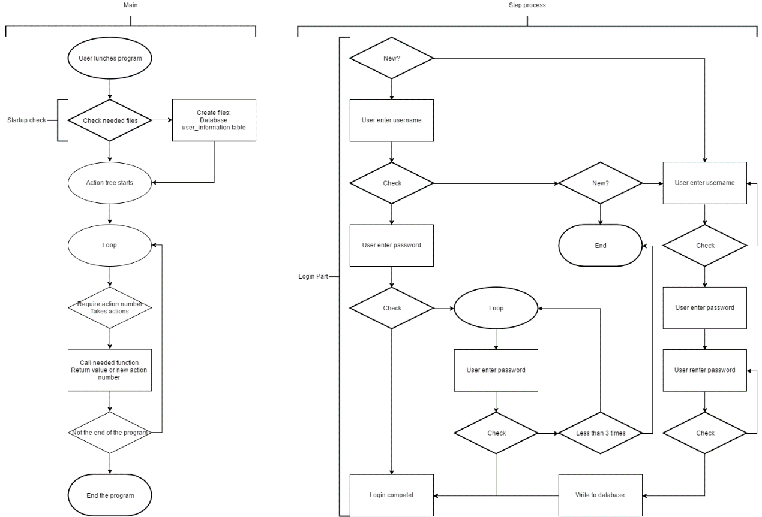

Note:

1. All the function base on the actions_tree need to return needed their own value and the value of the next action
2. In the *username*_schedules table, the event level is in the following order:
3. Highest
4. Medium
5. Lowest